Distribusi Responden Berdasarkan Usia
Statistics
Usia
N | Valid | 65
 | Missing | 0

Usia
 |  | Frequency | Percent | Valid Percent | Cumulative Percent
Valid | 20-30 Tahun | 4 | 6.2 | 6.2 | 6.2
 | 31-40 Tahun | 29 | 44.6 | 44.6 | 50.8
 | 41-50 Tahun | 22 | 33.8 | 33.8 | 84.6
 | 51-60 Tahun | 10 | 15.4 | 15.4 | 100.0
 | Total | 65 | 100.0 | 100.0

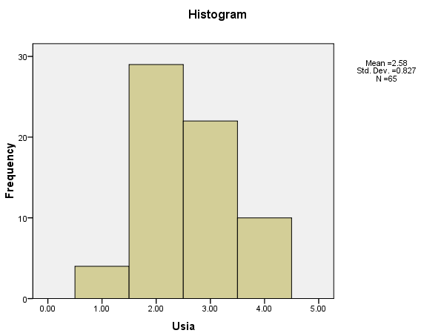

Distribusi Responden Berdasarkan Lama Bekerja
Statistics
LamaBekerja
N | Valid | 65
 | Missing | 0

LamaBekerja
 |  | Frequency | Percent | Valid Percent | Cumulative Percent
Valid | <!0 Tahun | 4 | 6.2 | 6.2 | 6.2
 | <15 Tahun | 29 | 44.6 | 44.6 | 50.8
 | <20 Tahun | 22 | 33.8 | 33.8 | 84.6
 | <25 Tahun | 10 | 15.4 | 15.4 | 100.0
 | Total | 65 | 100.0 | 100.0

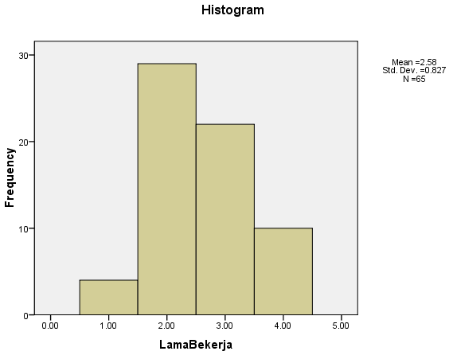

Distribusi Responden Berdasarkan Tingkat Pendidikan
Statistics
Tingkatpendidikan
N | Valid | 65
 | Missing | 0

Tingkatpendidikan
 |  | Frequency | Percent | Valid Percent | Cumulative Percent
Valid | SMA | 19 | 29.2 | 29.2 | 29.2
 | D-3 | 5 | 7.7 | 7.7 | 36.9
 | S1 | 30 | 46.2 | 46.2 | 83.1
 | S2 | 10 | 15.4 | 15.4 | 98.5
 | S3 | 1 | 1.5 | 1.5 | 100.0
 | Total | 65 | 100.0 | 100.0

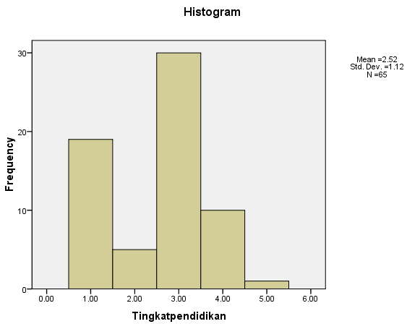

Data Distribusi Frekuensi Jawaban Responden
Variabel Ketepatan Waktu (X1)

Statistics
 |  | X1.1 | X1.2 | X1.3
N | Valid | 65 | 65 | 65
 | Missing | 0 | 0 | 0

X1.1
 |  | Frequency | Percent | Valid Percent | Cumulative Percent
Valid | Cukup Setuju | 6 | 9.2 | 9.2 | 9.2
 | Setuju | 37 | 56.9 | 56.9 | 66.2
 | Sangat Setuju | 22 | 33.8 | 33.8 | 100.0
 | Total | 65 | 100.0 | 100.0

X1.2
 |  | Frequency | Percent | Valid Percent | Cumulative Percent
Valid | Tidak Setuju | 2 | 3.1 | 3.1 | 3.1
 | Cukup Setuju | 6 | 9.2 | 9.2 | 12.3
 | Setuju | 47 | 72.3 | 72.3 | 84.6
 | Sangat Setuju | 10 | 15.4 | 15.4 | 100.0
 | Total | 65 | 100.0 | 100.0

X1.3
 |  | Frequency | Percent | Valid Percent | Cumulative Percent
Valid | Tidak Setuju | 2 | 3.1 | 3.1 | 3.1
 | Cukup Setuju | 8 | 12.3 | 12.3 | 15.4
 | Setuju | 46 | 70.8 | 70.8 | 86.2
 | Sangat Setuju | 9 | 13.8 | 13.8 | 100.0
 | Total | 65 | 100.0 | 100.0

Distribusi Jawaban Responden
Variabel Menggunakan Peralatan Kantor dengan baik (X2)

Statistics
 |  | X2.1 | X2.2 | X2.3
N | Valid | 65 | 65 | 65
 | Missing | 0 | 0 | 0

X2.1
 |  | Frequency | Percent | Valid Percent | Cumulative Percent
Valid | Cukup Setuju | 6 | 9.2 | 9.2 | 9.2
 | Setuju | 39 | 60.0 | 60.0 | 69.2
 | Sangat Setuju | 20 | 30.8 | 30.8 | 100.0
 | Total | 65 | 100.0 | 100.0

X2.3
 |  | Frequency | Percent | Valid Percent | Cumulative Percent
Valid | Cukup Setuju | 6 | 9.2 | 9.2 | 9.2
 | Setuju | 41 | 63.1 | 63.1 | 72.3
 | Sangat Setuju | 18 | 27.7 | 27.7 | 100.0
 | Total | 65 | 100.0 | 100.0

Distribusi Jawaban Responden
Variabel Tanggungjawab tinggi (X3)

Statistics
 |  | X3.1 | X3.2 | X3.3
N | Valid | 65 | 65 | 65
 | Missing | 0 | 0 | 0

X3.1
 |  | Frequency | Percent | Valid Percent | Cumulative Percent
Valid | Cukup Setuju | 8 | 12.3 | 12.3 | 12.3
 | Setuju | 41 | 63.1 | 63.1 | 75.4
 | Sangat Setuju | 16 | 24.6 | 24.6 | 100.0
 | Total | 65 | 100.0 | 100.0

X3.3
 |  | Frequency | Percent | Valid Percent | Cumulative Percent
Valid | Cukup Setuju | 4 | 6.2 | 6.2 | 6.2
 | Setuju | 44 | 67.7 | 67.7 | 73.8
 | Sangat Setuju | 17 | 26.2 | 26.2 | 100.0
 | Total | 65 | 100.0 | 100.0

Distribusi Jawaban Responden
Variabel Ketaatan Terhadap Aturan (X4)

Statistics
 |  | X4.1 | X4.2 | X4.3 | X4.4
N | Valid | 65 | 65 | 65 | 65
 | Missing | 0 | 0 | 0 | 0

X4.1
 |  | Frequency | Percent | Valid Percent | Cumulative Percent
Valid | Cukup Setuju | 8 | 12.3 | 12.3 | 12.3
 | Setuju | 36 | 55.4 | 55.4 | 67.7
 | Sangat Setuju | 21 | 32.3 | 32.3 | 100.0
 | Total | 65 | 100.0 | 100.0

X4.3
 |  | Frequency | Percent | Valid Percent | Cumulative Percent
Valid | Cukup Setuju | 4 | 6.2 | 6.2 | 6.2
 | Setuju | 40 | 61.5 | 61.5 | 67.7
 | Sangat Setuju | 21 | 32.3 | 32.3 | 100.0
 | Total | 65 | 100.0 | 100.0

X4.4
 |  | Frequency | Percent | Valid Percent | Cumulative Percent
Valid | Cukup Setuju | 4 | 6.2 | 6.2 | 6.2
 | Setuju | 45 | 69.2 | 69.2 | 75.4
 | Sangat Setuju | 16 | 24.6 | 24.6 | 100.0
 | Total | 65 | 100.0 | 100.0

Distribusi Jawaban Responden Prestasi Kerja (Y)

Statistics
Y1
N | Valid | 65
 | Missing | 0

Y1
 |  | Frequency | Percent | Valid Percent | Cumulative Percent
Valid | Cukup Setuju | 3 | 4.6 | 4.6 | 4.6
 | Setuju | 46 | 70.8 | 70.8 | 75.4
 | Sangat Setuju | 16 | 24.6 | 24.6 | 100.0
 | Total | 65 | 100.0 | 100.0

Y2
 |  | Frequency | Percent | Valid Percent | Cumulative Percent
Valid | Cukup Setuju | 2 | 3.1 | 3.1 | 3.1
 | Setuju | 44 | 67.7 | 67.7 | 70.8
 | Sangat Setuju | 19 | 29.2 | 29.2 | 100.0
 | Total | 65 | 100.0 | 100.0

Y3
 |  | Frequency | Percent | Valid Percent | Cumulative Percent
Valid | Cukup Setuju | 4 | 6.2 | 6.2 | 6.2
 | Setuju | 49 | 75.4 | 75.4 | 81.5
 | Sangat Setuju | 12 | 18.5 | 18.5 | 100.0
 | Total | 65 | 100.0 | 100.0

Y4
 |  | Frequency | Percent | Valid Percent | Cumulative Percent
Valid | Cukup Setuju | 11 | 16.9 | 16.9 | 16.9
 | Setuju | 46 | 70.8 | 70.8 | 87.7
 | Sangat Setuju | 8 | 12.3 | 12.3 | 100.0
 | Total | 65 | 100.0 | 100.0

UJI VALIDITAS
- Variabel Ketepatan Waktu (X1)

Correlations
 |  | X1
X1.1 | Pearson Correlation | .835**
 | Sig. (2-tailed) | .000
 | N | 65
X1.2 | Pearson Correlation | .787**
 | Sig. (2-tailed) | .000
 | N | 65
X1.3 | Pearson Correlation | .705**
 | Sig. (2-tailed) | .000
 | N | 65
**. Correlation is significant at the 0.01 level (2-tailed).
- Variabel Menggunakan Peralatan Kantor dengan Baik (X2)
Correlations
 |  | X2
X2.1 | Pearson Correlation | .715**
 | Sig. (2-tailed) | .000
 | N | 65
X2.2 | Pearson Correlation | .906**
 | Sig. (2-tailed) | .000
 | N | 65
X2.3 | Pearson Correlation | .894**
 | Sig. (2-tailed) | .000
 | N | 65
**. Correlation is significant at the 0.01 level (2-tailed).

- Variabel Tanggungjawab Tinggi (X3)

Correlations
 |  | X3
X3.1 | Pearson Correlation | .916**
 | Sig. (2-tailed) | .000
 | N | 65
X3.2 | Pearson Correlation | .879**
 | Sig. (2-tailed) | .000
 | N | 65
X3.3 | Pearson Correlation | .825**
 | Sig. (2-tailed) | .000
 | N | 65
**. Correlation is significant at the 0.01 level (2-tailed).

- Variabel Ketaatan Terhadap Aturan (X4)

Correlations
 |  | X4
X4.1 | Pearson Correlation | .782**
 | Sig. (2-tailed) | .000
 | N | 65
X4.2 | Pearson Correlation | .859**
 | Sig. (2-tailed) | .000
 | N | 65
X4.3 | Pearson Correlation | .870**
 | Sig. (2-tailed) | .000
 | N | 65
X4.4 | Pearson Correlation | .791**
 | Sig. (2-tailed) | .000
 | N | 65
**. Correlation is significant at the 0.01 level (2-tailed).

- Variabel Prestasi Kerja (Y)

Correlations
 |  | Y
Y1.1 | Pearson Correlation | .737**
 | Sig. (2-tailed) | .000
 | N | 65
Y1.2 | Pearson Correlation | .808**
 | Sig. (2-tailed) | .000
 | N | 65
Y1.3 | Pearson Correlation | .784**
 | Sig. (2-tailed) | .000
 | N | 65
Y1.4 | Pearson Correlation | .789**
 | Sig. (2-tailed) | .000
 | N | 65
**. Correlation is significant at the 0.01 level (2-tailed).

UJI RELIABILITAS

- Variabel Ketepatan Waktu (X1)
Case Processing Summary
 |  | N | %
Cases | Valid | 65 | 100.0
 | Excludedª | 0 | .0
 | Total | 65 | 100.0
a. Listwise deletion based on all variables in the procedure.

Reliability Statistics
Cronbach's Alpha | N of Items
.667 | 3

Item-Total Statistics
 | Scale Mean if Item Deleted | Scale Variance if Item Deleted | Corrected Item-Total Correlation | Cronbach's Alpha if Item Deleted
X1.1 | 7.9538 | .670 | .609 | .399
X1.2 | 8.2154 | .672 | .460 | .604
X1.3 | 8.0769 | .822 | .385 | .685

Scale Statistics
Mean | Variance | Std. Deviation | N of Items
12.1231 | 1.391 | 1.17935 | 3

- Variabel Menggunakan Peralatan Kantor Dengan Baik (X2)
Case Processing Summary
 |  | N | %
Cases | Valid | 65 | 100.0
 | Excludedª | 0 | .0
 | Total | 65 | 100.0
a. Listwise deletion based on all variables in the procedure.

Reliability Statistics
Cronbach's Alpha | N of Items
.777 | 3

Item-Total Statistics
 | Scale Mean if Item Deleted | Scale Variance if Item Deleted | Corrected Item-Total Correlation | Cronbach's Alpha if Item Deleted
X2.1 | 7.9077 | .991 | .506 | .815
X2.2 | 8.0000 | .719 | .789 | .523
X2.3 | 7.9385 | .527 | .652 | .720

Scale Statistics
Mean | Variance | Std. Deviation | N of Items
11.9231 | 1.510 | 1.22866 | 3

- Variabel Tanggungjawab Tinggi (X3)

Case Processing Summary
 |  | N | %
Cases | Valid | 65 | 100.0
 | Excludedª | 0 | .0
 | Total | 65 | 100.0
a. Listwise deletion based on all variables in the procedure.

Reliability Statistics
Cronbach's Alpha | N of Items
.839 | 3

Item-Total Statistics
 | Scale Mean if Item Deleted | Scale Variance if Item Deleted | Corrected Item-Total Correlation | Cronbach's Alpha if Item Deleted
X3.1 | 7.6462 | 1.357 | .760 | .737
X3.2 | 7.4462 | 1.845 | .749 | .745
X3.3 | 7.4000 | 1.931 | .641 | .835

Scale Statistics
Mean | Variance | Std. Deviation | N of Items
11.2462 | 3.563 | 1.88771 | 3

- Variabel Ketaatan terhadap Aturan (X4)

Case Processing Summary
 |  | N | %
Cases | Valid | 65 | 100.0
 | Excludedª | 0 | .0
 | Total | 65 | 100.0
a. Listwise deletion based on all variables in the procedure.

Reliability Statistics
Cronbach's Alpha | N of Items
.843 | 4

Item-Total Statistics
 | Scale Mean if Item Deleted | Scale Variance if Item Deleted | Corrected Item-Total Correlation | Cronbach's Alpha if Item Deleted
X4.1 | 11.5846 | 2.622 | .631 | .821
X4.2 | 11.7538 | 2.126 | .707 | .793
X4.3 | 11.6769 | 2.222 | .746 | .770
X4.4 | 11.5538 | 2.657 | .654 | .814

Scale Statistics
Mean | Variance | Std. Deviation | N of Items
15.5231 | 4.066 | 2.01640 | 4

- Variabel Prestasi Kerja (Y)

Case Processing Summary
 |  | N | %
Cases | Valid | 65 | 100.0
 | Excludedª | 0 | .0
 | Total | 65 | 100.0
a. Listwise deletion based on all variables in the procedure.

Reliability Statistics
Cronbach's Alpha | N of Items
.784 | 4

Item-Total Statistics
 | Scale Mean if Item Deleted | Scale Variance if Item Deleted | Corrected Item-Total Correlation | Cronbach's Alpha if Item Deleted
Y1.1 | 12.3385 | 1.602 | .527 | .762
Y1.2 | 12.2769 | 1.485 | .638 | .706
Y1.3 | 12.4154 | 1.559 | .612 | .721
Y1.4 | 12.5846 | 1.465 | .589 | .733

Scale Statistics
Mean | Variance | Std. Deviation | N of Items
16.5385 | 2.534 | 1.59175 | 4

UJI ASUMSI KLASIK
- Uji Multikolinieritas

 | Coefficientsª
 | Model |  | Unstandardized Coefficients |  |  | Standardized Coefficients |  | t |  | Sig. |  | Collinearity Statistics
 |  |  | B | Std. Error |  | Beta |  |  |  |  |  | Tolerance |  | VIF
 | 1 | (Constant) | 1.744 |  | .497 |  |  |  | 3.509 |  | .001
 |  | X1 | .407 |  | .125 |  | .402 |  | 3.269 |  | .002 |  | .743 |  | 1.345
 |  | X2 | .068 |  | .157 |  | .070 |  | .436 |  | .665 |  | .431 |  | 2.321
 |  | X3 | .178 |  | .099 |  | .282 |  | 1.808 |  | .076 |  | .463 |  | 2.158
 |  | X4 | -.050 |  | .135 |  | -.063 |  | -.371 |  | .712 |  | .385 |  | 2.594
a. Dependent Variable: Y

- Uji Heteroskedastisitas

Correlations
 |  |  | Abs_Res
Spearman's rho | X1 | Correlation Coefficient | -.073
 |  | Sig. (2-tailed) | .565
 |  | N | 65
 | X2 | Correlation Coefficient | -.035
 |  | Sig. (2-tailed) | .781
 |  | N | 65
 | X3 | Correlation Coefficient | .097
 |  | Sig. (2-tailed) | .443
 |  | N | 65
 | X4 | Correlation Coefficient | -.071
 |  | Sig. (2-tailed) | .574
 |  | N | 65

- Uji Normalitas

One-Sample Kolmogorov-Smirnov Test
 |  | Unstandardized Residual
N |  | 65
Normal Parametersª | Mean | .0000000
 | Std. Deviation | .32697523
Most Extreme Differences | Absolute | .111
 | Positive | .111
 | Negative | -.070
Kolmogorov-Smirnov Z |  | .898
Asymp. Sig. (2-tailed) |  | .396
a. Test distribution is Normal.

- Uji Linieritas

Model Summary and Parameter Estimates
Dependent Variable:Y
Equation | Model Summary |  |  |  |  | Parameter Estimates
 | R Square | F | df1 | df2 | Sig. | Constant | b1
Linear | .255 | 21.586 | 1 | 63 | .000 | 2.068 | .511
The independent variable is X1.

Model Summary and Parameter Estimates
Dependent Variable:Y
Equation | Model Summary |  |  |  |  | Parameter Estimates
 | R Square | F | df1 | df2 | Sig. | Constant | b1
Linear | .158 | 11.788 | 1 | 63 | .001 | 2.602 | .386
The independent variable is X2.

Model Summary and Parameter Estimates
Dependent Variable:Y
Equation | Model Summary |  |  |  |  | Parameter Estimates
 | R Square | F | df1 | df2 | Sig. | Constant | b1
Linear | .162 | 12.173 | 1 | 63 | .001 | 3.181 | .254
The independent variable is X3.

Model Summary and Parameter Estimates
Dependent Variable:Y
Equation | Model Summary |  |  |  |  | Parameter Estimates
 | R Square | F | df1 | df2 | Sig. | Constant | b1
Linear | .096 | 6.701 | 1 | 63 | .012 | 3.185 | .245
The independent variable is X4.

Uji Regresi Linier Berganda

Model Summary^{b}
Model | R | R Square | Adjusted R Square | Std. Error of the Estimate | Durbin-Watson
1 | .570ª | .325 | .280 | .33770 | 1.242
a. Predictors: (Constant), X4, X1, X3, X2
b. Dependent Variable: Y

ANOVA^{b}
Model |  | Sum of Squares | df | Mean Square | F | Sig.
1 | Regression | 3.292 | 4 | .823 | 7.217 | .000ª
 | Residual | 6.842 | 60 | .114
 | Total | 10.135 | 64
a. Predictors: (Constant), X4, X1, X3, X2
b. Dependent Variable: Y

Coefficientsª
Model |  | Unstandardized Coefficients |  | Standardized Coefficients | t | Sig. | Collinearity Statistics
 |  | B | Std. Error | Beta |  |  | Tolerance | VIF
1 | (Constant) | 1.744 | .497 |  | 3.509 | .001
 | X1 | .407 | .125 | .402 | 3.269 | .002 | .743 | 1.345
 | X2 | .068 | .157 | .070 | .436 | .665 | .431 | 2.321
 | X3 | .178 | .099 | .282 | 1.808 | .076 | .463 | 2.158
 | X4 | -.050 | .135 | -.063 | -.371 | .712 | .385 | 2.594
a. Dependent Variable: Y

